SQL Database Project: Kestrel Air Flight Operations Database
Olutayo Akinsola ADIGUN | Student ID: 25058362 | Synthetic regional airline database (SQLite) | Data Science | Individual report

1. Overview
This database models an imaginary UK regional airline, Kestrel Air, flying a hub-and-spoke network from Manchester and Edinburgh in 2026. It has 10 related tables, 73 columns and 344,046 rows. Five tables exceed the 1,000-row requirement: booking_extras (185,225), bookings (105,480), passengers (50,000), flight_cabins (2,158) and flights (1,073). The data is treated as extracted on 29 October 2026: earlier flights are history (with weather, delays and ratings) and later flights are only scheduled, with partial bookings. All four scales of measurement are covered (Section 3). The SQLite file is kestrel_air.db (about 30 MB).

2. How the data was generated
All data was created by one Python script, generate_airline_db.py (Section 6), using only standard libraries and no downloaded data. Passengers, flights and bookings are fictional; the only hand-typed real-world facts are general knowledge used as parameters (IATA codes, approximate airport coordinates and elevations, typical seat counts, ranges and monthly temperatures). A fixed random seed (2026) makes the output repeatable: a re-run gave identical table contents (checked by hashing every row). Tables are created in dependency order, and values follow simple cause-and-effect rules rather than uniform noise; these rules are modelling assumptions, not measured airline behaviour.
Network (26 airports, 4 aircraft types, 8 aircraft, 60 routes). Manchester and Edinburgh are the hubs; 30 hub-to-destination pairs give 60 directed routes with Haversine distances. Each route has a category (Domestic, Business, Leisure or Mixed) and a weekly frequency, which drive seasonality, weekday pattern, pricing and load.
Schedule (1,073 flights; 2,158 flight cabins). For each route and day of 2026, expected departures equal weekly frequency × 0.10 (to suit eight aircraft) × a seasonal factor × a weekday factor, rounded randomly to at most two flights. Leisure frequency rises in summer (×1.4 to ×1.6, June to August) and falls in winter (×0.55 in January and February); business frequency dips in August (×0.70) and December (×0.80); Domestic and Mixed routes average the two. Business services favour weekdays (weekends about ×0.5) and leisure services favour Friday to Sunday.
Aircraft assignment. Departures are processed in time order. An aircraft needs enough range (80% of its range, 10% margin) and must be free, meaning its previous arrival plus a 45-minute turnaround (0 overlaps; the smallest gap is exactly 45 minutes). An aircraft already at the departure airport is preferred; otherwise any free aircraft is used and its location is reset to the new destination. No positioning flights are stored, so 609 of 1,065 consecutive assignments (57%) start away from the aircraft's previous destination (see Section 5). Flights with no free aircraft are dropped.
Weather, delays and status. For flights up to the extraction date, origin temperature follows the airport's climate (seasonal curve plus noise), weather depends on temperature, and weather, hour of day and chance drive delays and cancellations. Mean departure delay is about 7 min in clear or cloudy weather, 19 min in thunderstorms and 41 min in snow. Flights: 895 Completed, 8 Cancelled, 5 Diverted, 165 Scheduled.
Passengers (50,000). Names come from invented pools and emails are unique @example.com addresses (a domain reserved for documentation). Birth years are triangular between 1940 and 2008 (adults), sign-ups become more frequent over time (June 2025 to October 2026) and 62% of home countries are the United Kingdom. Loyalty tier is derived after the bookings exist, not random: Silver, Gold and Platinum for 3, 6 and 10 or more flown bookings.
Bookings (105,480; one row per passenger seat on a flight). Seats sold depend on route type, month, weekday and noise (load factor). Only passengers already registered on the booking date can book, and activity is heavy-tailed (log-normal): a few passengers fly often, most once or twice (30,147 passengers have a booking). Lead time is log-normal (median about three weeks) and fares follow a demand curve: Economy averages £205 booked 0 to 7 days ahead and £122 booked 31 or more days ahead. Seats are unique within a flight and a passenger holds at most one seat per flight.
Status and survey. Bookings are 87% Flown, 7% Booked (future), 3% Cancelled, 2% No-show and 1% Refunded (flight cancelled). Fares are stored for all bookings; baggage weights and satisfaction ratings are generated only for flown bookings. About one third of flown bookings (33.5%) get a rating (1 to 5), more often after long delays (45% for arrival delays of 60 minutes or more, 33% otherwise). Ratings average 4.15 when the flight arrives within 15 minutes of schedule and 3.07 when it is 60 or more minutes late.
Add-ons (booking_extras 185,225; extras 12). Purchase probabilities are deliberately linked (bag with priority boarding, lounge with fast track, hot meal with drink), so the data contains associations intentionally embedded in the synthetic generation process; they do not describe real customer behaviour. Example: lounge access → fast-track security has support 0.037, confidence 0.59 and lift 5.0, calculated over all 105,480 bookings (no add-on = empty basket).
Validation. Checks on the supplied database; the last row shows known limitations (Section 5).
Check | Result | Check | Result
PRAGMA integrity_check | ok | Foreign-key violations (foreign_key_check) | 0
Bookings dated before passenger sign-up | 0 | Bookings dated after the flight's departure | 0
Cabins sold beyond seat capacity | 0 | Seats sold twice on one flight | 0
Aircraft overlaps (45-minute turnaround included) | 0 | Ratings or baggage on unflown bookings | 0
Passengers holding the same flight twice | 0 | Cancelled-flight bookings not Refunded | 0
Aircraft flights starting away from last destination | 609 of 1,065 | Overlapping flights held by one passenger | 357 pairs

3. Database schema
The schema has 10 tables and 11 foreign keys (Figure 1). Flights join a route (between two airports) to an aircraft, which belongs to an aircraft type; flight_cabins holds one row per flight and cabin class. Bookings resolve the many-to-many link between passengers and flights, and the composite foreign key (flight_id, cabin_class) guarantees that the booked cabin exists on that flight. booking_extras resolves bookings to extras. The table below lists the four measurement scales; dates and times are ISO-8601 text.
Scale | Columns
Nominal | weather_condition, flight_status, route_category, booking_status, payment_method, booking_channel, home_country, region, extra_name, extra_category, manufacturer, engine_type, iata_code, first_name, last_name, seat_number
Ordinal | cabin_class (Economy < Premium Economy < Business), loyalty_tier (Standard < Silver < Gold < Platinum), satisfaction_rating (1 to 5)
Interval | origin_temperature_c, scheduled_departure and scheduled_arrival (ISO text), booking_date, signup_date, birth_year, year_built, elevation_m, latitude, longitude (zero is arbitrary)
Ratio | fare_gbp, base_fare_gbp, unit_price_paid, list_price_gbp, checked_baggage_kg, departure_delay_min, arrival_delay_min, distance_km, seats_capacity, quantity, weekly_frequency, range_km, cruise_speed_kmh, seats_economy, seats_premium, seats_business
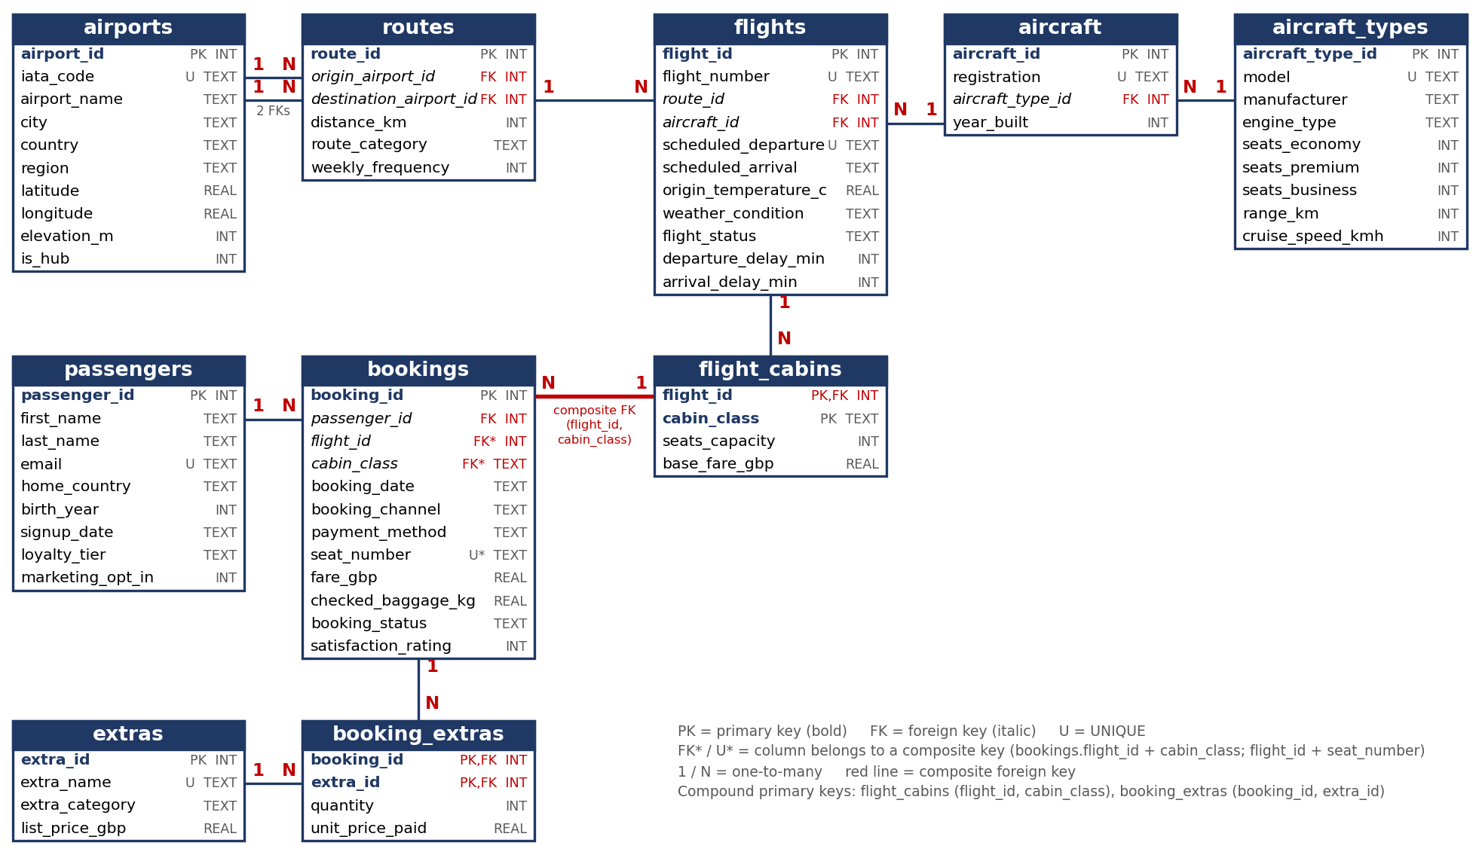
Figure 1: Entity relationship diagram: 10 tables, 73 columns, compound and composite keys marked.

4. Justification for separate tables and constraints
Table | Rows | Reason for a separate table
airports | 26 | Airport facts stored once; routes reference them twice (origin and destination).
aircraft_types, aircraft | 4, 8 | Seats, range and speed belong to the model, not each aeroplane (3NF); 8 aircraft use 4 types.
routes | 60 | Distance, category and frequency belong to a directed airport pair; UNIQUE (origin, destination) prevents duplicates.
flights | 1,073 | One row per departure, holding the facts that vary per flight: times, weather, status and delays.
flight_cabins | 2,158 | Capacity and list fare differ per flight and cabin. Compound primary key (flight_id, cabin_class).
passengers | 50,000 | Person details are stored once rather than repeated on each booking.
bookings | 105,480 | One row per seat; resolves passengers to flights. Composite foreign key (flight_id, cabin_class) ensures the cabin exists on that flight.
extras | 12 | Lookup of add-ons and list prices; avoids inconsistent spellings.
booking_extras | 185,225 | Resolves bookings to extras and records the price paid. Compound key (booking_id, extra_id) stops duplicate add-ons; basket table for association rules.
Constraints. SQLite enforces foreign keys only when PRAGMA foreign_keys = ON is set, which the script does. Every table has a primary key; required attributes use NOT NULL, while selected attributes deliberately allow missing values. UNIQUE covers iata_code, registration, model, email, extra_name, (origin, destination) on routes, (flight_number, scheduled_departure) on flights and (flight_id, seat_number) on bookings, so no seat is sold twice. CHECK restricts value lists (status, category, cabin, tier, channel, payment method), ranges (rating 1 to 5, latitude −90 to 90, birth_year 1920 to 2008, fare > 0, baggage ≥ 0, delays within a fixed range) and origin ≠ destination. NULL marks a value that is unknown or not yet applicable: weather and temperature for scheduled flights (165), delays for scheduled and cancelled flights (173), seat_number for cancelled bookings (3,081), checked_baggage_kg for unflown bookings (13,677) and satisfaction_rating for unflown bookings and flown bookings with no survey reply (74,746 in total). Indexes on foreign keys and dates speed up joins and date queries.

5. Ethical and data privacy discussion
Synthetic data. No real person is represented, so there is no consent or re-identification issue. Names come from generic pools and any match with a real person is coincidental; emails use example.com, a domain reserved for documentation, so they cannot be contacted. No third-party data set was copied.
The design is realistic on purpose and follows UK GDPR and Data Protection Act 2018 principles: it minimises data (birth year, not date; home country, not address; no phone, passport, card number or special-assistance flag; only the payment type) and supports purpose limitation through the marketing_opt_in consent flag. A live system would pseudonymise passengers, restrict access, set retention periods and erase by anonymising the passenger while keeping flight data.
Re-identification and fairness. Home country, birth year, loyalty tier and booking dates could single out a member of a small group, so results would be aggregated before sharing. Tier-based benefits or pricing could disadvantage occasional or last-minute travellers and would need a fairness assessment. Survey ratings are biased because unhappy passengers reply more often.
Limits of realism. All distributions are my modelling assumptions, not airline statistics, so the database shows technique and is not evidence about any real airline or its customers. Main simplifications: the schedule is thinned (eight aircraft, about three flights a day) and times are local; aircraft continuity is not modelled (609 of 1,065 consecutive assignments, 57%, start away from the previous destination, because no positioning flights are stored and cancelled or diverted flights still move the aircraft); passengers are sampled independently for each flight, so one person can hold overlapping flights (357 pairs among active bookings) and bookings do not form coherent trips; loyalty tier is a single end-of-period value from all flown bookings, not a history; and the add-on associations and the delay-to-satisfaction link are parameters I chose, not findings about customers.

6. Code
The generator is commented throughout to explain each design decision; it is generate_airline_db.py (about 850 lines) in the GitHub repository https://github.com/Olutayo122/SQL-db. Running python generate_airline_db.py recreates kestrel_air.db in seconds with identical table contents and prints the validation counts, deliberate NULL counts and association-rule support, confidence and lift.

7. Evidence: first rows of each generated table
Figures 2 to 4 are screenshots of kestrel_air.db in a database viewer, showing the first rows of flights, bookings and booking_extras (row counts are in the viewer headers); the other tables are described in Section 4 and Figure 1.
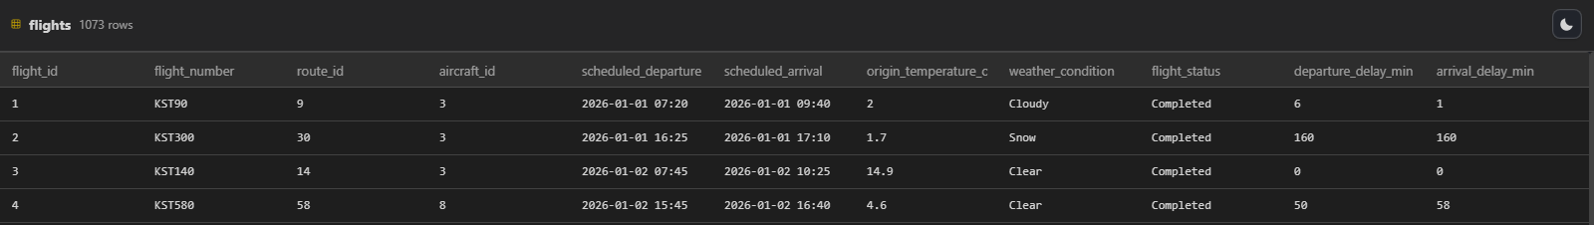
Figure 2. flights (1,073 rows): weather, status and delays
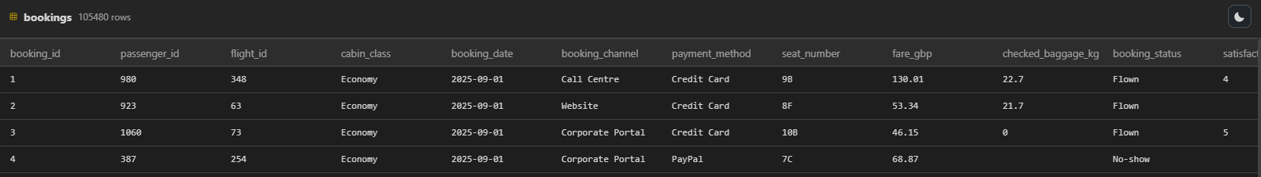
Figure 3. bookings (105,480 rows): composite-key columns, fares, status and NULL baggage or ratings
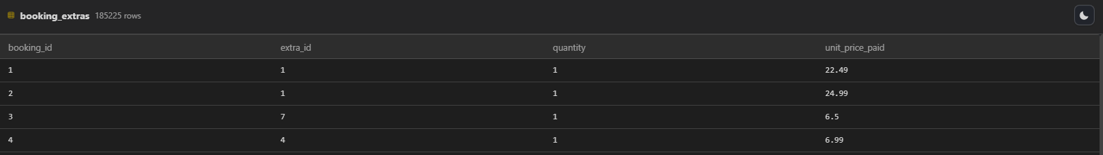
Figure 4. booking_extras (185,225 rows): compound key (booking_id, extra_id)

